

MACHAKOS UNIVERSITY

CENTER OF OPEN, DISTANCE AND e-LEARNING

IN COLLABORATION WITH

SCHOOL OF ENGINEERING AND TECHNOLOGY

DEPARTMENT OF COMPUTING AND INFORMATION TECHNOLOGY.

SCO 208 OBJECT ORIENTED ANALYSIS AND DESIGN/
SIT 264 UML

WRITTEN BY:

Mr. Martin Kimeu

Copyright © Machakos University, 2020
All Rights Reserved

SEP, 2021

USE CASE DIAGRAMS

Unit Structure

- Introduction
- Requirement capture with use case
- Building blocks of use case diagram
- Actors
- Dependencies
- Generalizations

- INTRODUCTION

To model a system the most important aspect is to capture the dynamic behavior. To clarify a bit in details, dynamic behavior means the behaviour of the system when it is running /operating.

So only static behaviour is not sufficient to model a system rather dynamic behaviour is more important than static behaviour. In UML there are five diagrams(Use case ,activity, sequence, collaboration and Statechart)available to model dynamic nature and use case diagram is one of them. Now as we have to discuss that the use case diagram is dynamic in nature there should be some internal or external factors for making the interaction.

These internal and external agents are known as actors. So use case diagrams are consists of actors, use cases and their relationships. The diagram is used to model the system/subsystem of an application. A single use case diagram captures a particular functionality of a system.

So to model the entire system numbers of use case diagrams are used.

- REQUIREMENT CAPTURE WITH USE CASE

The purpose of use case diagram is to capture the dynamic aspect of a system. But this definition is too generic to describe the purpose.

Because other four diagrams (activity, sequence, collaboration and Statechart) are also having the same purpose. So we will look into some specific purpose which will distinguish it from other four diagrams.

Use case diagrams are used to gather the requirements of a system including internal and external influences. These requirements are mostly design requirements. So when a system is analyzed to gather its functionalities use cases are prepared and actors are identified.

Now when the initial task is complete use case diagrams are modelled to present the outside view.

So in brief, the purposes of use case diagrams can be as follows:

- BUILDING BLOCKS OF USE CASE DIAGRAM

As UML describes the real time systems it is very important to make a conceptual model and then proceed gradually. Conceptual model of UML can be mastered by learning the following three major elements:

  - UML building blocks

  - Rules to connect the building blocks
  - Common mechanisms of UML

This chapter describes all the UML building blocks. The building blocks of UML can be defined as:

Things Relationships Diagrams

(1) Things:

Things are the most important building blocks of UML. Things can be: Structural

Behavioral

Grouping Annotational

Structural things:

The Structural things define the static part of the model. They represent physical and conceptual elements. Following are the brief descriptions of the structural things.

Class:
Class represents set of objects having similar responsibilities.
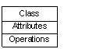

Interface:

Interface defines a set of operations which specify the responsibility of a class.
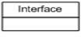

Collaboration:
Collaboration defines interaction between elements.
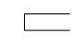

Use case:

Use case represents a set of actions performed by a system for a specific goal.

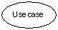

Component:
Component describes physical part of a system.
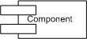

Node:
A node can be defined as a physical element that exists at run time.
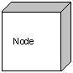

Behavioral things:

A behavioral thing consists of the dynamic parts of UML models. Following are the behavioral things:

Interaction:

Interaction is defined as a behavior that consists of a group of messages exchanged among elements to accomplish a specific task.
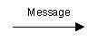

State machine:

State machine is useful when the state of an object in its life cycle is important. It defines the sequence of states an object goes through in response to events. Events are external factors responsible for state change.
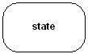

Grouping things:

Grouping things can be defined as a mechanism to group elements of a UML model together. There is only one grouping thing available:

Package:

Package is the only one grouping thing available for gathering structural and behavioral things.
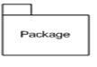

Annotational things:

Annotational things can be defined as a mechanism to capture remarks, descriptions, and comments of UML model elements. Note is the only one Annotational thing available.

Note:
A note is used to render comments, constraints etc of an UML element.
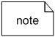

(2) Relationship :

Relationship is another most important building block of UML. It shows how elements are associated with each other and this association describes the functionality of an application.

There are four kinds of relationships available.

Dependency:

Dependency is a relationship between two things in which change in one element also affects the other one.
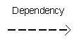

Association:

Association is basically a set of links that connects elements of an UML model. It also describes how many objects are taking part in that relationship.
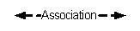

Generalization:

Generalization can be defined as a relationship which connects a specialized element with a generalized element. It basically describes inheritance relationship in the world of objects.
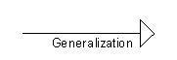

Realization:

Realization can be defined as a relationship in which two elements are connected. One element describes some responsibility which is not implemented and the other one implements them. This relationship exists in case of interfaces.
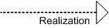

(3) UML Diagrams:

UML diagrams are the ultimate output of the entire discussion. All the elements, relationships are used to make a complete UML diagram and the diagram represents a system.

The visual effect of the UML diagram is the most important part of the entire process. All the other elements are used to make it a complete one.

UML includes the following nine diagrams and the details are described in the following chapters.

- Class diagram
- Object diagram
- Use case diagram
- Sequence diagram
- Collaboration diagram
- Activity diagram
- Statechart diagram
- Deployment diagram
- Component diagram

We would discuss all these diagrams in subsequent chapters of this book.

- ACTORS

An actor is a user or external system with which a system being modeled interacts. For example, our project management system involves various types of users, including project managers, resource managers, human resources, and system administrators. These users are all actors.

An actor is external to a system, interacts with the system, may be a human user or another system, and has goals and responsibilities to satisfy in interacting with the system. Actors address the question of who and what interacts with a system. In the UML, an actor is shown as a "stick figure" icon, or as a class marked with the actor keyword and labeled with the name of the actor class.

Following figure shows various actors associated with the project management system:

A project manager

Responsible for ensuring that a project delivers a quality product within specified time and cost, and within specified resource constraints

A resource manager

Responsible for ensuring that trained and skilled human resources are available for projects

A human resource

Responsible for ensuring that worker skills are maintained, and that quality work is completed for a project

A system administrator

Responsible for ensuring that a project management system is available for a projectqqq

A backup system

Responsible for housing backup data for a project management system
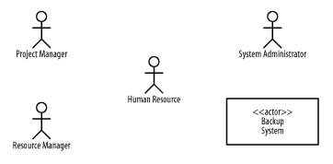

Use case guidelines for use case models

Use case diagrams are considered for high level requirement analysis of a system. So when the requirements of a system are analyzed the functionalities are captured in use cases.

So we can say that uses cases are nothing but the system functionalities written in an organized manner. Now the second things

which are relevant to the use cases are the actors. Actors can be defined as something that interacts with the system.

The actors can be human user, some internal applications or may be some external applications. So in a brief when we are planning to draw an use case diagram we should have the following items identified.

Functionalities to be represented as an use case
Actors
Relationships among the use cases and actors.

Use case diagrams are drawn to capture the functional requirements of a system. So after identifying the above items we have to follow the following guidelines to draw an efficient use case diagram.

The name of a use case is very important. So the name should be chosen in such a way so that it can identify the functionalities performed.

Give a suitable name for actors.
Show relationships and dependencies clearly in the diagram.

Do not try to include all types of relationships. Because the main purpose of the diagram is to identify requirements.

Use note when ever required to clarify some important points.

The following is a sample use case diagram representing the order management system. So if we look into the diagram then we will find three use cases (Order, SpecialOrder and NormalOrder) and one actor which is customer.

The SpecialOrder and NormalOrder use cases are extended from Order use case. So they have extends relationship. Another importantpoint is to identify the system boundary which is shown in the picture. The actor Customer lies outside the system as it is an external user of the system.
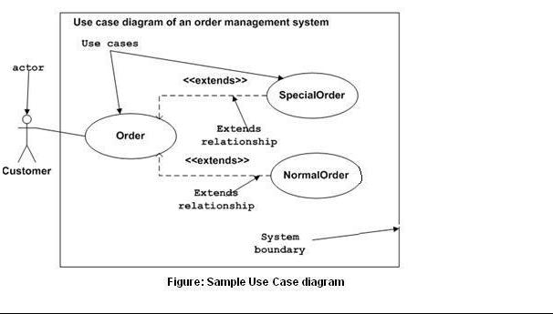

- DEPENDENCIES

A model may have many use cases, so how do we organize the use cases that define what a system should do? And how do we use this information about use cases to determine how best to execute a project while considering how use cases are related to one another, including what some use cases might have in common, and also taking into account use cases that are options of other use cases? Specialized types of dependencies, called include and extend dependencies,

address these questions; The next few sections discuss these specialized types of dependencies.

Include Dependencies

Perhaps we wish to log the activities of project managers, resources managers, and system administrators as they interact with the project management system. Figure A below elaborates on the use cases and figure B show that the activities of the project manager, resource managers, and system administrators are logged when they are performing the use cases shown in the diagram. Thus, logging activities are common to these three use cases. We can use an include dependency to address this type of situation by factoring out and reusing common behavior from multiple use cases.

Figure A.Use cases with common behavior
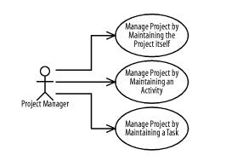

An include dependency from one use case (called the base use case) to another use case (called the inclusion use case) indicates that the base use case will include or call the inclusion use case. A use case may include multiple use cases, and it may be included in multiple use cases. An include dependency is shown as a dashed arrow from the base use case to the inclusion use case marked with the include keyword. The base use case is responsible for identifying where in its behavior sequence or at which step to include the inclusion use case. This identification is not done in the UML diagram, but rather in the textual description of the base use case.

B refines A using include dependencies. The Log Activity use case is common to the Manage Project, Manage Resource, and Administer System use cases, so it is factored out and included by these use cases.

Figure B. Include dependencies
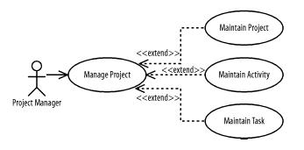

You can use an include dependency when a use case may be common to multiple other use cases and is therefore factored out of the different use cases so that it may be reused. The Log Activity use case in B is included in the Manage Project, Manage Resource, and Administer System use cases. Consequently, you must analyze and develop that use case before you develop the three use cases that depend on it.

Extend Dependencies

Projects are made of activities, and activities are made of tasks. Figure C elaborates the Manage Project use case and shows that a project manager may manage projects by maintaining the project itself, its activities, or its tasks. Thus, maintaining the project, its activities, and its tasks are options of managing a project. You can use an extend dependency to address this situation by factoring out optional behavior from a use case.

Figure C. Use cases with optional behavior
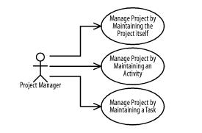

An extend dependency from one use case (called the extension use case) to another use case (called the base use case) indicates that the extension use case will extend (or be inserted into) and augment the base use case. A use case may extend multiple use cases, and a use case may be extended by multiple use cases. An extend dependency is shown as a dashed arrow from the extension use case to the base use case marked with the extend keyword. The base use case is responsible for identifying at which steps in its behavior sequence the extending use cases may be inserted.

Figure D refines Figure C using extend dependencies. The Maintain Project, Maintain Activity, and Maintain Task use cases are options of the Manage Project use case, so Manage Project is factored out and extends those three use cases.

Figure D. Simple extend dependencies
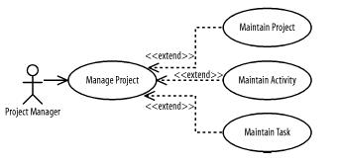

The location in a base use case at which another behavior sequence may be inserted is called an extension point. Extension points for a use case may be listed in a compartment labeled "Extension Points" where each extension point is shown inside the compartment with an extension-point name followed by a colon followed by a suitable description of the location of the extension point in the use case's

behavior sequence. Locations may be described as being before, after, or in-the-place-of a step in the base use case's behavior sequence. For example, the Manage Project use case may have a behavior sequence for finding a project on which to work followed by an extension point named Project Selected followed by another behavior. The Project Selected extension point may be described as occurring after a project is found but before it is actually worked on.

An extend dependency is responsible for defining when an extension use case is inserted into the base use case by specifying a condition that must be satisfied for the insertion to occur. The condition may be shown following the extend keyword enclosed within square brackets followed by the extension point name enclosed in parentheses. For example, other use cases may be inserted into the Project Selected extension point just described for the Manage Project use case. Such behavior sequences may include reviewing and updating project information, or selecting a specific version of a project before managing the details of the project in the succeeding behavior sequences.

- GENERALIZATIONS

Actors may be similar in how they use a system; for example, project managers, resource managers, and system administrators may log in and out of our project management system. Use cases may be similar in the functionality provided to users; for example, a project manager may publish a project's status in two ways: by generating a report to a printer or by generating a web site on a project web server.

Given that there may be similarities between actors and use cases, how do we organize the use cases that define what a system should do? And how do we use the information about similarities between actors and use cases to determine how best to execute a project? Specialized types of generalizations, called actor and use case generalizations, address these questions.

Actor Generalizations

Figure E shows that project managers, resource managers, and system administrators may log in and out of the project management system. Thus, logging in and out is common to these actors. Actor generalizations address such situations by factoring out and reusing similarities between actors.

Figure E
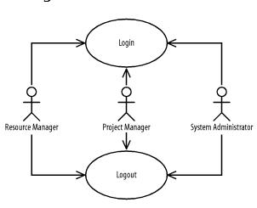

An actor generalization from a more specific, or specialized, actor to a more general, or generalized, actor indicates that instances of the more specific actor may be substituted for instances of the more general

actor. An actor may specialize multiple actors, and an actor may be specialized by multiple actors. An actor generalization between actors is shown as a solid-line path from the more specific actor to the more general actor, with a large hollow triangle at the end of the path connected to the more general actor.

Figure F refines Figure Eusing actor generalizations between actors. A human resource initiates the Login and Logout use cases. Project managers, resource managers, and system administrators are human resources.

Figure F
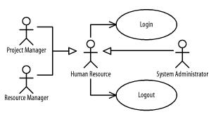

Use an actor generalization between actors when one actor is similar to another, but has specific interactions in which it participates or initiates. For example, any human resource may log in and out, but project managers, resources managers, and system administrators make more specialized use of the project management system. Because

the Project Manager, Resource Manager, and System Administrator actors are

specialized Human Resource actors, they benefit from the use cases in which the Human Resource actor is involved. Therefore, by developing the Login and Logout use cases, we provide the functionality described by those use cases for all the actors of our system.

Use-Case Generalizations

Figure G shows that a project manager may publish a project's status in two ways: by generating a report to a printer or by generating a web site on a project web server. Thus, publishing a project's status and all the processing involved in collecting and preparing the data for publication is common to these use cases. You can use a use-case generalization to address this situation by factoring out and reusing similar behavior from multiple use cases.
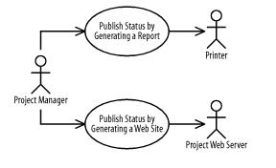

Figure G

A use-case generalization from a more specific, or specialized, use case to a more general, or generalized, use case indicates that the more specific use case receives or inherits the actors, behavior sequences, and extension points of the more general use case, and that instances of the more specific use case may be substituted for instances of the more general use case. The specific use case may include other
actors, define new behavior sequences and extension points, and modify or specialize the behavior sequences it receives or inherits. A use case may specialize multiple use cases, and a use case may be specialized by multiple use cases. A use-case generalization between use cases is shown as a solid-line path from the more specific use case to the more general use case, with a large hollow triangle at the end of the path connected to the more general use case.

Question 1

A hospital admission system records the details of the admission, treatment and discharge of all patients. It also provides a number of official reports to satisfy the requirements of external authorities. Admission consists of the following tasks: Administration staff enters the patient’s personal details from a completed hospital admission form and sometimes helping them to complete the form. Next they allocate appropriate hospital accommodation if one or more nights stay is required. Following this they assign a doctor to attend for an initial examination, and check (in the case that private medical care is required) that the patient has valid medical insurance. Doctors and nurses use the system to record medical care given to patient during their stay. (This medical care consists of treatments given and drugs administered). Only a doctor may prescribe drugs to a patient, and this information is also recorded in the system. Both doctors and nurses may administer drugs and doses are similarly recorded. Only doctors have the authority to discharge a patient, and this information is, again, recorded within the system.
From the above narrative
i) Identify the use cases and actors of the hospital admissions system.
ii) Develop a possible use case diagram for the above narrative

Question 2
CASE STUDY: Hospital Management System
Hospital management system helps in registering information about patients and handles patient’s query. A unique ID is generated for each patient after registration. This helps in implementing customer relationship management and also maintains medical history of patient. This system also monitors the doctor appointments, when the ID is generated the patient receives the appointment time and number from the receptionist and accordingly visit the doctor. This system also deals with testing appointments as and when ID is generated the patient receives the appointment time and number and accordingly undergoes the test.
It also deals with bed allotments to various patients by checking their ID. It also undergoes various operations by diagnosing the patients. The system identifies whether the person is a doctor or staff and handles various activities such as draw salary and give salary, also it adds doctor/staff information into database. This system is responsible for handling various other activities like deleting, editing doctor/staff information into the database. As per doctor diagnoses the patient, gives treatment and gives suggestions to patients and prescribe laboratory tests and medicines. This system also takes care of medical equipment, doctor visit, vitals recording, patient case sheet, diet ordering, blood requisition, transfer information and discharge information, maintenance of wards, inter and intrawards transfers also it generates patient’s discharge summary which includes patients health at the time of discharge, medical history, various diagnosis and drug prescriptions, history of patients illness and course in hospital. Patient can pay bill through credit card, cash or cheque whose information is maintained by this system.
Draw a possible use case diagram to represent the above scenario.

QUESTION 3
Identify the actors and the objects in the following scenario to register a patient in a hospital management system:
The administrator enters the patient’s name, address, date of birth and emergency contact details into the system. If the patient has only public health insurance, the administrator enters the patient’s medicare number, and the system verifies this with government health database. If the patient also has private health insurance, then the administrator enters also the patient’s private health insurance details, and the system verifies these details with the private health insurance system. When these details are verified as correct, the system saves the patient's details and confirms the registration.
Question 4
You have been given the following case study ;
CASE STUDY - LIBRARY (BORROW BOOK) MANAGEMENT SYSTEM
Librarian lends books
Librarian maintains the list of all the members of library
Borrower makes reservation online
Borrower can remove reservation online
Librarian issues books to the borrower
Librarian calculates dues to be paid by the borrower
Borrower issues/returns books
Librarian places order about the requirements to the master librarian
Librarian updates the system
Master librarian maintains librarians

- Identify the actors and Functionalities in the above case
- Make a Use case drawing of the UML diagram from the case study given above

